Software Requirement Specification
Online Shopping System



Submitted by
Muhammad Adnan (S25BINFT7M04008)
Submitted To : Syed Ali Nawaz Shah

Department of Information Technology
Faculty of Computing
The Islamia University of Bahawalpur

Meeting Details
Sr No | Details | Date | Supervisor Signature
Summary
Shopping for clothes online often feels like a guessing game, leading to the "return culture" that frustrates both customers and brands. This project introduces a streamlined e-commerce platform designed to replace measurement charts with intuition. The heart of the system is "The 15-Second Fit Quiz," a feature that shifts the focus from raw numbers to body geometry and personal style.
1. The Vision & Foundation
The primary purpose of this system is to act as a definitive roadmap for a platform where "Personalized" isn't just a buzzword, but a functional reality. By integrating body-shape-aware technology, the scope extends beyond a simple cart and checkout; it creates a curated environment where every item a user sees is filtered through the lens of their specific silhouette.
From a product perspective, the system is a complete, standalone ecosystem. It manages everything from secure payments and real-time inventory to a sophisticated recommendation engine that translates quiz answers into specific product suggestions.
2. User-Centric Design
The platform is built for three distinct groups:
- The Practical Shopper: People who value their time and want to avoid the hassle of shipping back ill-fitting clothes.
- The Style Enthusiast: Users who want to discover how different cuts like oversized or tailored look on their specific frame.
- The Administrator: Staff who use data-driven insights to see which body shapes are trending and adjust inventory accordingly.
While many competitors use complex sizing tools, our Literature Review showed a gap in the market for speed. By using a heuristic-based approach rather than requiring a tape measure, we prioritize user engagement without sacrificing accuracy.
3. Technical & Functional Excellence
Built on a modern stack featuring React/Flutter for a smooth interface and Node.js/Python for high-speed logic, the system is designed for performance.
- Core Functionality: The 15-Second Fit Quiz uses a visual, 5-question format to identify shapes (like the Inverted Triangle or Pear). Immediately after, the Personalized Storefront updates to show "Best Fit" badges on recommended items.
- Security & Speed: We’ve set high benchmarks for Non-Functional Requirements, ensuring that all body data is encrypted with AES-256 and that the personalized filtering happens in under 2 seconds to keep the shopping flow seamless.

Table of Contents

1. Introduction 4

1.1. Purpose 4
1.2. Scope 4
1.3. Product Perspective 4
1.4. User Characteristics 4
1.5. Similar apps and systems/Literature Review 4
1.6. Proposed Technologies 4

2. Requirements 5
2.1. Function Requirements 5
2.1.1. Sign Up 5
2.2. Non-Functional Requirements 5

3. Use Cases and Flow of Processes 6
3.1. Use Case 1 7

4. References 8

1. Introduction
1.1. Purpose
The purpose of this document is to define the functional and non-functional requirements for the "Online Shopping System." It serves as a guide for developers, designers, and stakeholders to ensure the platform delivers a personalized shopping experience via body-shape-aware technology.
1.2. Scope
The system is a web and mobile-based retail platform. While it includes standard e-commerce features (browsing, cart, checkout), its primary differentiator is the 15-Second Fit Quiz, an algorithmic tool that filters the catalog based on user-input body metrics and style preferences.
1.3. Product Perspective
This system acts as a standalone retail ecosystem. It interfaces with:
- Payment Gateways: For secure transactions.
- Inventory Management: To sync real-time stock levels.
- Recommendation Engine: To process Quiz data and suggest specific SKUs.

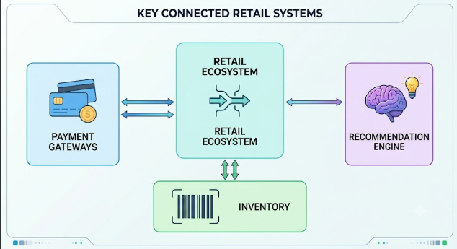

1.4. User Characteristics
- General Shoppers: Users seeking convenience and accurate sizing to avoid the hassle of returns.
- Administrators: Staff managing inventory, analyzing quiz data trends, and updating collections.
- Style Enthusiasts: Users looking for "curated" looks tailored to their specific silhouette.
1.5. Similar Apps and Systems/Literature Review
Existing systems like Stitch Fix or ASOS’s Fit Assistant provide similar utility. However, many rely on complex measurements. Our proposed system focuses on a high-speed (15-second) heuristic-based quiz that prioritizes "Body Shape" (e.g., Hourglass, Pear, Athletic) over just numerical measurements.
1.6. Proposed Technologies
- Frontend: React.js or Flutter (for cross-platform mobile).
- Backend: Node.js or Python (Django) to handle the Quiz logic.
- Database: PostgreSQL for user profiles and product data.
- AI/ML: Simple decision tree algorithms for the Fit Quiz recommendations.

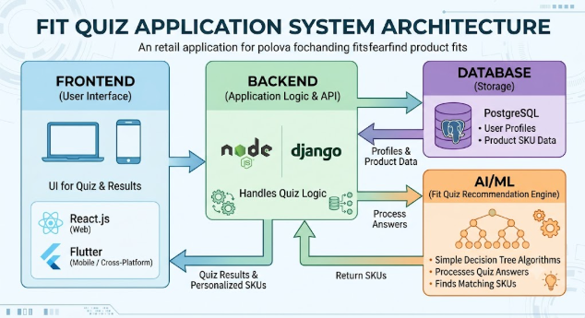

2. Requirements
Overall Requirements of the Web Application consist functional and non-functional requirements .

2.1. Functional Requirements
- The 15-Second Fit Quiz: The system must present a 5-question visual quiz to determine body shape and fit preference (Tight, Regular, Oversized).
- Personalized Storefront: Once the quiz is completed, the "Recommended for You" section must prioritize clothes tagged for that user's shape.
- Order Management: Users can track, cancel, or return orders.

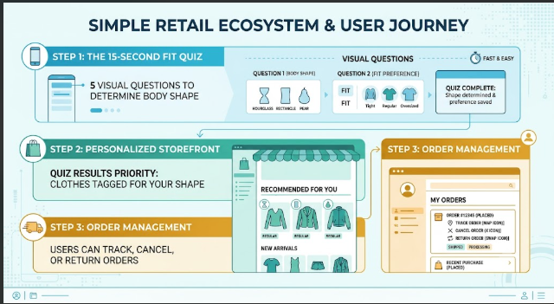

2.1.1. Sign Up
- The system shall allow users to register via Email, Google, or Phone Number.
- Post-registration, users are prompted to take the Fit Quiz to "Complete Profile."

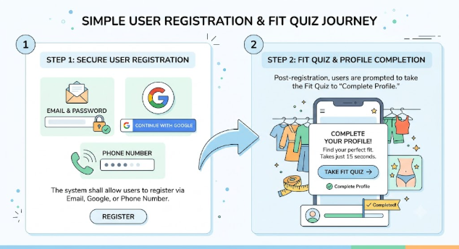

2.2. Non-Functional Requirements
- Usability: The Fit Quiz must be completed in under 15 seconds.
- Performance: Product filtering based on quiz results should occur in seconds.
- Security: User body metrics and personal data must be encrypted using AES-256.
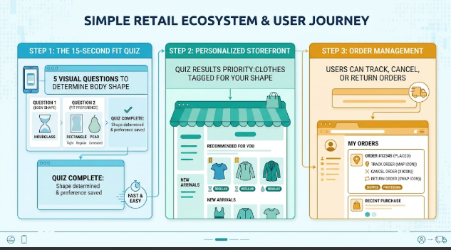

3. Use Cases and Flow of Processes
3.1. Use Case 1: Finding the Perfect Fit
Actor: Registered User Pre-condition: User is logged in.

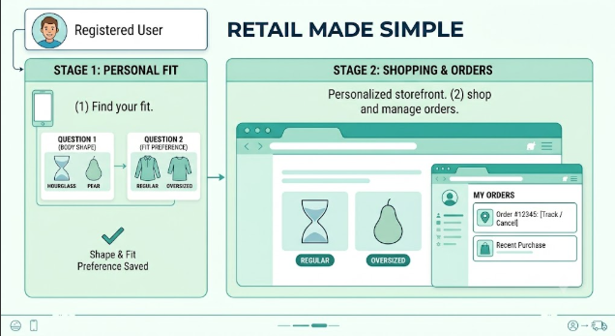

Step | Action
1 | User selects "Take the 15-Second Fit Quiz."
2 | System displays visual icons for body shapes (e.g., Inverted Triangle, Rectangle).
3 | User selects their shape and enters height/weight (optional).
4 | System processes data and updates the catalog view.
5 | User sees "Best Fit" badges on specific items.

4. References
- IEEE Std 830-1998, IEEE Recommended Practice for Software Requirements Specifications.
- Analysis of E-commerce Personalization Algorithms (Journal of Software Engineering, 2025).
- UI/UX Design Patterns for Rapid User Input (Design Weekly).

